**Management Principles for Engineers**

***Lecture Notes***



***Compiled By:***

**Career Development Centre**

**SRM IST**

**Table of Contents**

UNIT V

5.1 People Management

5.2 Attracting a quality workforce

5.3 Developing a quality workforce

5.4 Environment and diversity

5.5 Internal environment and organisational culture

5.6 Ethics

# 

# UNIT V

People Management - Diversity and the importance of people - Attracting a quality workforce - The recruiting process - Developing a quality workforce - Environment and diversity - Environment and competitive advantage - Internal environment and organisational culture - Leadership and organisational culture . Ethics - Cultural issues in ethical behaviour - Ethics in the workplace - Ethical dilemma

## 5.1 People Managment

People management, also known as human resource management (HRM), encompasses the tasks of recruitment, management, and providing ongoing support and direction for the employees of an organization. These tasks can include the following: compensation, hiring, performance management, organization development, safety, wellness, benefits, employee motivation, communication, administration, and training.

**5.1.1 Diversity and the importance of people**

With flattening structures within organisations proving to be more effective than the traditional hierarchical structures, the use of teams has grown. Incorporating the concepts of self‐directed teams, traditional teams or cross‐functional teams, the ability to work in teams is essential. The focus on strategic achievement means that the image of HR needs to move from a cost centre to an investment centre. Accountability through scorecard targets is the norm in most organisations, with emphasis on ensuring that employees are well trained, skilled and engaged to deliver the highest productivity. Many organisations have seen devolution of HR processes to line managers, with the productivity improvement within the teams. HR needs to ensure this targeted group is fully supported. This means that HR policies must be in place to ensure that there is no detraction from the highest possible productivity through negative influences such as bullying, discrimination or the lack of value for diversity in the workplace.

**Why people make the difference**

Even with the guidance of the best strategies and supported by the best designs, an organisation must be well staffed with capable and committed people if it is to fully achieve its objectives. There is strong connection between how firms manage their people and the economic results achieved, organisations perform better when they treat their members better. The management practices associated with successful organisations are employment security, decentralisation, use of teams, good remuneration, extensive training and information sharing. Too many organisations fail to operate in this manner, are referred as ‘toxic workplaces’ that treat their employees poorly. Researchs show a positive relationship between HR policies and organisational performance, stating: ‘human resources are key to organizational success or failure’. Initial decisions on HR policies and practices have long term impact on company performance. Founders showing strong and early commitments to a positive HR philosophy are able to operate in the future with fewer managers and with greater reliance on self‐management by their employees. Focus on people is good for business. Organisational policies that link employee remuneration with individual and organisational performance are on the rise, as are policies that provide flexibility in working hours and the design of jobs. Performance management systems have also grown in popularity. Many organisations use performance appraisals to evaluate past performance and to determine the training and development needs of their employees, while many use appraisals to align individual and corporate objectives.

The use of high‐quality HR practices experienced steep increase in their share price over the years. HRM is taking on higher significance because of the effects of the ageing population, the shrinking executive talent pool and the steady fall in the retirement age for many in the workforce. Companies are increasingly looking for the best staff at the same time that the pool of top‐quality people shrinks due to these kinds of factors.

**The diversity advantage**

Diversity is linked with competitive advantage. It brings to problem‐solving and strategy formulation an array of talents, perspectives, experiences and worldviews that broaden any organisation’s repertoire of skills and capabilities. That’s one side of the diversity story — finding the best talent available. The other side of the story is tapping it — finding ways to allow diversity to work its advantages to help create high‐performing organisations.

Job‐relevant talent is not restricted because of anyone’s race, gender, religion, marital or parental status, ethnicity or other diversity characteristics. Organisation should not let these characteristics interfere with finding, hiring and developing the best job talents available. They must place a primacy on people with the talent and desire to do good work. While cultural and gender diversity have received significant attention in the literature, little attention has been paid to the impact of age diversity on HRM practices

**HRM**

The process of **human resource management (HRM)** involves attracting, developing and maintaining a talented and energetic workforce to support the organisation’s mission, objectives and strategies. In order for strategies to be well implemented, workers with relevant skills and enthusiasm are needed. A key task of HRM is to make them available.

**Employment discrimination**

**Discrimination** involves ‘making a distinction between individuals or groups so as to advantage some and disadvantage others’. Employers specifically and managers generally must take care in their HRM practices not to discriminate between people on the basis of characteristics such as age, disability, marital status, ethnicity, family responsibilities, social origin.

**The HRM process**

The HRM process involves attracting, developing and maintaining a quality workforce. The first responsibility of *attracting a quality workforce* includes HR planning, recruitment and selection. The second responsibility of *developing a quality workforce* includes employee orientation, training and development, and career planning and development. The third responsibility of *maintaining a quality workforce* includes management of employee retention and turnover, performance appraisal and remuneration and benefits.

**Strategic HRM**

Any organisation should at all times have the right people available to do the work required to achieve and sustain competitive advantage. **Strategic HRM** applies the HRM process to ensure the effective accomplishment of the organisation’s mission. Strategic HRM mobilises human resources to implement strategies and sustain competitive advantage. This requires a top‐level commitment to **HR planning**, a process of analysing staffing needs and planning how to satisfy these needs in a way that best serves the organisation’s mission, objectives and strategies.

The major elements in strategic human resource planning are shown in figure. The process begins with a review of the organisation’s mission, objectives and strategies. This establishes a frame of reference for forecasting HR needs and labour supplies, both within and outside the organisation. Ultimately, the planning process should help managers identify staffing requirements, assess the existing workforce, and determine what additions and/or replacements are required to meet future needs.

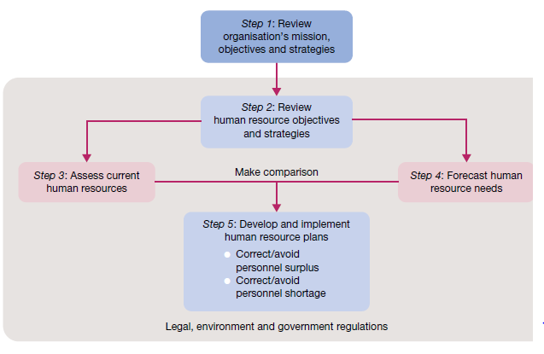

**Fig 5.1.1 Steps in strategic HR planning**

The foundations for HR planning are set by **job analysis** — the orderly study of job facts to determine just what is done, when, where, how, why, and by whom in existing or potential new jobs. The job analysis provides useful information that can then be used to write and/or update a **job description**. This is a written statement of job duties and responsibilities. The information in a job analysis can also be used to create a **job specification** that lists the qualifications — such as education, previous experience and skill requirements — needed by any person hired for or placed in a given job.

## 5.2 Attracting a quality workforce

With a HR plan prepared, the process of attracting a quality workforce begins. An advertisement once run by the Motorola Corporation identified the goal this way: ‘Productivity is learning how to hire the person who is right for the job’. To attract the right people to its workforce, an organisation must first know exactly what it is looking for — it must have a clear understanding of the jobs to be done and the talents required to do them well. Then it must have the systems in place to excel at employee recruitment and selection.

**The recruiting process**

**Recruitment** is a set of activities designed to attract a *qualified* pool of job applicants to an organisation. Emphasis on the word ‘qualified’ is important. Effective recruiting should bring employment opportunities to the attention of people whose abilities and skills meet job specifications. The three steps in a typical recruitment process are advertising a job vacancy, preliminary contact with potential job candidates and initial screening to create a pool of qualified applicants. In university recruiting, for example, advertising is done by the company posting short job descriptions in print or online through a careers resource or campus placement centre and/or in the student newspaper. Preliminary contact is made after candidates register for interviews with company recruiters on campus. This typically involves a short 20‐ to 30‐minute interview, during which the candidate presents a written résumé and briefly explains his or her job qualifications. As part of the initial screening, the recruiter shares interview results and résumés from the campus visits with appropriate line managers. Decisions are then made about who to include in the final pool of candidates to be invited for further interviews during a formal visit to the organisation. Given that both the shortage of skilled people in some sectors and an ageing workforce are creating greater competition for the best people, recruiting has become a crucial HRM process for organisations seeking to retain or build their competitive advantage.

**External and internal recruitment**

*External recruitment*, in which job candidates are sought from outside the hiring organisation. Specialist websites such as naukri (www.naukri.com), newspapers, employment agencies, universities, personal contacts, walk‐ins, employee referrals and even people in competing organisations are all sources of external recruits. Competition is especially tough in the very tight labour markets characteristic of the contemporary economy.

*Internal recruitment* seeks applicants from inside the organisation. Most organisations have a procedure for announcing vacancies through newsletters, electronic bulletin boards and the like. They also rely on managers to recommend subordinates as candidates for advancement. Internal recruitment creates opportunities for long‐term career paths. Both recruitment strategies offer potential advantages and disadvantages. External recruiting brings in outsiders with fresh perspectives. It also provides access to specialised expertise or work experience not otherwise available from insiders. Internal recruitment is usually less expensive. It also deals with people whose performance records are well established. A history of serious internal recruitment can also be encouraging to employees. It builds loyalty and motivation, showing that you can advance in the organisation by working hard and achieving high performance at each point of responsibility.

**Realistic job previews**

**Realistic job previews** that give the candidate *all* pertinent information about the job and organisation without distortion and before the job is accepted. Instead of ‘selling’ only positive features of a job, this approach tries to be realistic and balanced in the information provided. It tries to be fair in depicting actual job and organisational features, both favourable and unfavourable, the candidate gets a more complete and balanced view of the future employment possibility. This helps to establish more ‘realistic’ job expectations when starting work as a new employee.

With expectations being more realistic, the individual is better prepared to handle the ‘ups and downs’ of a new job. A better perspective on the employment relationship, higher levels of early job satisfaction, and less inclination to quit prematurely are among the benefits of this interview approach. In recruiting the best staff, providing realistic job previews may provide a competitive edge. Rather than having questions about the future direction of the organisation, many job seekers are far more interested in finding out about the colleagues with whom they will work, the culture of the company, and even the location of the desk at which they will work. In a competitive job market, like that for the best accounting graduates, providing realistic job previews can be a key means of attracting the best people and minimising any concerns they may have before starting a job.

**Making selection decisions**

The process of **selection** involves choosing from a pool of applicants the person or persons who offer the greatest performance potential. Steps in a typical selection process are shown in figure. They are completion of a formal application form, interviewing, testing, reference checks, physical examination and final analysis and decision to hire or reject. As with all aspects of the HRM process, the best employers exercise extreme care in making selection decisions.

In using any selection devices, including such testing, it is important to know that they meet the important criteria of reliability and validity. Reliability means that the device is consistent in measurement; it returns the same results time after time. Validity means that there is a demonstrable relationship between a person’s score or rating on a selection device and eventual job performance. In simple terms, validity means that a good score really does predict good performance.

**Application forms**

The application form declares the individual to be a formal candidate for a job. It documents the applicant’s personal history and qualifications. The personal résumé is often included with the job application. This important document should accurately summarise an applicant’s special qualifications. Importantly, the application should request only information that is directly relevant to the job and the applicant’s potential job success.

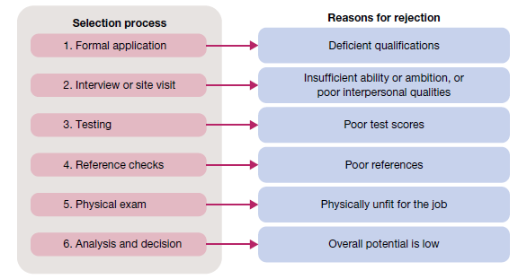

**Fig 5.2.1 Steps in the selection process: the case of a rejected job applicant**

**Interviews**

Interviews are extremely important in the selection process because of the information exchange they allow. It is a time when both the job applicant and potential employer can learn a lot about one another. However, interviews are also recognised as potential stumbling blocks in the selection process. The interviewer should not fall prey to personal biases and makes a judgement that fails to fullyconsider the applicant’s capabilities. Behavioural interview questions are becoming increasingly popular in many job interviews. Through such questions, applicants are invited to reflect on their own previous work and life experiences. Candidates might be asked to cite a time when they performed well under pressure or dealt effectively with a difficult customer or colleague, for example.

**Employment tests**

Testing is often used in the screening of job applicants. Some common employment tests are designed to identify intelligence, aptitudes, personality and interests; others ask the applicant to indicate how he or she would respond to a series of job‐relevant situations. Some corporations using psychological tests. Whatever test is used, however, the goal should be to gather information that will help predict the applicant’s eventual performance success. An employment test should meet the criteria of *reliability* and *validity*, and should be legally defensible on the grounds that it actually measures an ability required to perform the job. New developments in testing extend the process into actual demonstrations of job‐relevant skills and personal characteristics. An **assessment centre** evaluates a person’s potential by observing his or her performance in activities designed to simulate daily work, such as interviews, group discussions, inbasket exercises, psychological tests and business games.

**Reference and background checks**

Reference checks are inquiries to previous employers, academic advisers, co‐workers and/or acquaintances regarding the qualifications, experience and past work records of a job applicant. Although they may be biased if friends are prearranged ‘to say the right things if called’, reference checks can be helpful in revealing important information not discovered elsewhere in the selection process. Some job candidates lie during job interviews. Lying is particularly common when candidates talk about their hobbies, past salaries or skills.

References given by a job applicant can also add credibility to an application if they include a legitimate and even prestigious list of persons. An organisation that does not disclose negative information about ex‐employees may be held responsible for economic losses suffered by another organisation that relied on this information when employing a new staff member. For this reason, references are becoming a less reliable source of information about potential employees as increasing numbers of employers provide only the bare minimum of information about departing staff. Some companies outsource reference checking to specialised providers in order to ensure that the most value is extracted from this process.

**Physical examinations**

Many organisations ask job applicants to take a physical examination. This health check helps ensure that the person is physically capable of fulfilling job requirements. It may also be used as a basis for enrolling the applicant in health‐related fringe benefits such as life, health and disability insurance programs. At a minimum, care must be exercised that any required test is job relevant and does not discriminate in any way against the applicant.

**Final decisions to hire or reject**

The best selection decisions are most likely to be those involving extensive consultation among the manager or team leader, potential co‐workers and HR staff. Importantly, the emphasis in selection must always be comprehensive and focus on all aspects of the person’s capacity to perform in a given job. After all, the selection decision poses major consequences for organisational performance and for the internal environment or work climate. Just as a ‘good fit’ can produce long‐term advantage, a ‘bad fit’ can be the source of many (and perhaps long‐term) problems.

## 5.3 Developing a quality workforce

When people join an organisation, they must ‘learn the ropes’ and become familiar with the way things are done. It is important that newcomers are helped to fit into the work environment in a way that furthers their development and performance potential. **Socialisation** is the process of influencing the expectations, behaviour and attitudes of a new employee in a way considered desirable by the organisation. The intent of socialisation in HRM is to help achieve the best possible fit between the individual, the job and the organisation.

**Employee orientation**

Socialisation of newcomers begins with **orientation** — a set of activities designed to familiarise new employees with their jobs, co‐workers and key aspects of the organisation as a whole. This includes clarifying the mission and culture, explaining operating objectives and job expectations, communicating policies and procedures, and identifying key personnel.

The first six months of employment are often crucial in determining how well someone will perform over the long term. It is a time when the original expectations are tested, and patterns are set for future relationships between an individual and employer. Unfortunately, orientation is sometimes neglected and newcomers are often left to fend for themselves. They may learn job and organisational routines on their own or through casual interactions with co‐workers, and they may acquire job attitudes the same way. The result is that otherwise well‐intentioned and capable persons may learn inappropriate attitudes and/or behaviours. Good orientation, on the other hand, enhances a person’s understanding of the organisation and adds purpose to his or her daily job activities. Increased performance, greater job satisfaction and greater work commitment are the desired results. Orientation is particularly important for employees being sent on international assignments.

**Training and development**

**Training** is a set of activities that provide the opportunity to acquire and improve job‐related skills. This applies both to the initial training of an employee and to upgrading or improving someone’s skills to meet changing job requirements. A major concern of employers is the lack of educational preparation of some workers for jobs, often high technology jobs, in the new workplace. These concerns even extend to the basic skills of reading, writing and arithmetic, as well as to computer skills. Progressive organisations offer extensive training programs to ensure that their workers always have the skills and computer literacy needed to perform well.

**On‐the‐job training**

*On‐the‐job training* takes place in the work setting while someone is doing a job. A common approach is job rotation that allows people to spend time working in different jobs to expand the range of their job capabilities. Another is **coaching**, in which an experienced person provides performance advice to someone else. One form of coaching is **mentoring**, in which employees at the early stages of their careers are formally assigned as protégés of senior people. The mentoring relationship gives them regular access to advice on developing skills and getting a good start in their careers. An informal type of coaching involves **modelling**. This occurs when someone demonstrates through day‐to‐day personal behaviour what is expected of others. One way to learn managerial skills, for example, is to observe and practise the techniques displayed by good managers. Modelling is a very important influence on behaviour in organisations.

**Off‐the‐job training**

*Off‐the‐job training* is accomplished outside the work setting. It may be done within the organisation at a separate training room or facility or at an offsite location. Examples of the latter include attendance at special training programs sponsored by universities, trade or professional associations, or consultants. The willingness of organisations to invest in training is a good indicator of their commitment to the people they hire. An important form of off‐the‐job training involves **management development**, designed to improve a person’s knowledge and skill in the fundamentals of management. For example, *beginning managers* often benefit from training that emphasises delegating duties; *middle managers* may benefit from training to better understand multifunctional viewpoints; *top managers* may benefit from advanced management training to sharpen their decision‐making and negotiating skills and to expand their awareness of corporate strategy and direction. Moves to blend different types of training are becoming increasingly popular. Because individuals have different learning styles and approaches, it makes sense to provide employees with a range of training options to meet their needs. E‐learning, for instance, uses the internet to encourage less pressured, more reflective, self‐paced learning. It can be used to supplement other methods such as outdoor experiences or face‐to‐face discussions.

**Performance management systems**

Performance has to be measured. With measurement comes the opportunity not only to document results but also to take steps towards their future improvement. Part of the HRM responsibility is design and implementation of a successful **performance management system**. This is a system that ensures that performance standards and objectives are set, that performance is regularly assessed for accomplishments, and that actions are taken to improve performance potential in the future. Unfortunately, many managers believe that the appraisal is the beginning and end of **performance management**. It is only one aspect of ongoing feedback and development, and a continuous process of setting goals and objectives, watching performance, and then giving and receiving feedback and ongoing coaching. Managers must ensure through performance management that all activities and outputs are aligned with strategic goals — thus ensuring the company can achieve competitive advantage through well‐trained and developed people. Performance management provides a direct link between ‘employee performance and organizational goals and makes the employee’s contribution “explicit”’.

**Purpose of performance appraisal**

Usually performance appraisal is a once‐a‐year contribution to feedback. It does not provide the ongoing coaching that allows for improvement, but instead measures the strengths and weaknesses of the employee. An appraisal is an important part of a performance management, because performance management is much more than performance appraisal. The process of formally assessing someone’s work accomplishments and providing feedback is **performance appraisal**. It serves two basic purposes in the maintenance of a quality workforce: evaluation and development. The *evaluation purpose* is intended to let people know where they stand relative to performance objectives and standards. The *development purpose* is intended to assist in their training and continued personal development. The evaluation purpose of performance appraisal focuses on past performance and measures results against standards. Performance is documented for the record and to establish a basis for allocating rewards. The manager acts in a *judgemental role* in which he or she gives a direct evaluation of another person’s accomplishments. The development purpose of performance appraisal, on the other hand, focuses on future performance and the clarification of success standards. It is a way of discovering performance obstacles and identifying training and development opportunities. Here the manager acts in a *counselling role*, focusing on a subordinate’s developmental needs. Like employment tests, any performance appraisal method can fulfil these purposes only when the criteria of *reliability* and *validity* are met. To be reliable, the method should consistently yield the same result over time and/or for different raters; to be valid, it should be unbiased and measure only factors directly relevant to job performance.Written documentation of performance appraisals and a record of consistent past actions will be required to back up any contested evaluations.

**Performance appraisal methods**

Organisations use a variety of performance appraisal methods. One of the simplest is a **graphic rating scale**, such as the example in figure . Such scales offer the appraisers checklists of traits or characteristics thought to be related to high‐performance outcomes in a given job. A manager rates the individual on each trait using a numerical score. The main appeal of graphic rating scales is that they are relatively quick and easy to complete. Their reliability and validity are questionable, however, because the categories and scores are subject to varying interpretations.

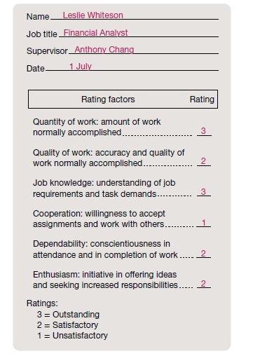

**Fig 5.3.2 Sample graphic rating scale for performance appraisal**

A more advanced approach is the **behaviourally anchored rating scale** (BARS), which offers an appraiser rating scales for actual behaviours that exemplify various levels of performance achievement in a job. Look at the case of a customer service representative illustrated in figure. Unsatisfactory performance is clearly defined as rude or disrespectful treatment of a customer. Because performance assessments are anchored to specific descriptions of work behaviour, a BARS is more reliable and valid than the graphic rating scale. The behavioural anchors can also be helpful in training people to master job skills of demonstrated performance importance.

The **critical‐incident technique** involves keeping a running log or inventory of effective and ineffective job behaviours. By creating a written record of positive and negative performance examples, this method documents success or failure patterns that can be specifically discussed with the individual. Using the case of the customer service representative again, a critical‐incidents log might contain the following types of entries: *positive example* — ‘Took extraordinary care of a customer who had purchased a defective item from a company store in another city’; *negative example* — ‘Acted rudely in dismissing the complaint of a customer who felt that a sale item was wrongly advertised’.

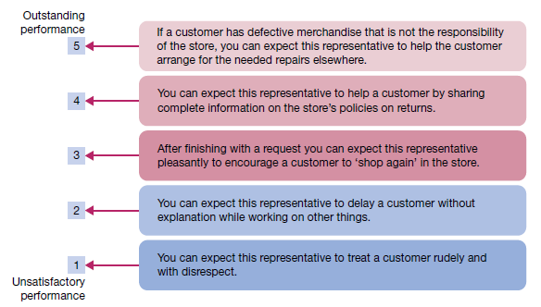

**Fig 5.3.2 Sample behaviourally anchored rating scale for performance appraisal**

Some performance management systems use **multiperson comparisons**, which formally compare one person’s performance with that of one or more others. Such comparisons can be used on their own or in combination with some other method. They can also be done in different ways. In *rank ordering*, all people being rated are arranged in order of performance achievement. The best performer goes at the top of the list, the worst performer at the bottom; no ties are allowed. In *paired comparisons*, each person is compared with every other person and rated as either the superior or the weaker member of the pair. After all paired comparisons are made, each person is assigned a summary ranking based on the number of superior scores achieved. In *forced distribution*, each person is placed into a frequency distribution that requires that a certain percentage fall into specific performance classifications, such as top 10 per cent, next 40 per cent, next 40 per cent and bottom 10 per cent. Not all performance appraisals are completed only by an employee’s immediate boss. It is increasingly popular today to expand the role of a job’s stakeholders in the appraisal process. The new workplace often involves use of *peer appraisal*, including in the process others who work regularly and directly with a job holder, and *upward appraisal*, including in the process subordinates reporting to the job holder. An even broader stakeholder approach is known as **360° feedback**, where superiors, subordinates, peers and even internal and external customers are involved in the appraisal of a job holder’s performance.

## 5.4 Environment and diversity

The modern manager should consider diversity to be another key to achieving competitive advantage. With changing demographics, organisational culture and diverse workforces, to remain successful in the dynamic, complex and ever changing environment of today the organisations must be prepared.

**Environment and competitive advantage**

Environmental shifts constantly affect companies and their operations. Companies, need to develop strategic or dynamic capabilities in order to advantageously compete in the face of these far reaching changes that emanate from the environment. **Strategic capabilities** are difficult to imitate, are of value to the customer, and are better than those possessed by the majority of competitors.8 An example is a unique or differentiated product or service. Taking the concept of strategic capabilities one step further, dynamic capabilities can be matched to environmental contingencies and opportunities, because they enable an organisation to reconfigure its resources to cope with exogenous shocks. **Dynamic capabilities** are physical (e.g. state‐of‐the‐art equipment or advantageous location), organisational (e.g. an outstanding sales force) and human (e.g. expertise in a specialised field). For this reason, in an ‘information is power’ age, the company that employs knowledgeable staff with a canny ability to scan the environment for shifts and ideas might gain a competitive advantage. Old levers of competition — labour, capital and land — are being supplemented by knowledge, and that most successful companies in the future will be those that learn how to exploit knowledge — knowledge about customer behaviour, markets, economies, technology — faster than their competitors.

**What is competitive advantage?**

Astute executives are ever alert to environmental trends that require adjustments in the ways their organisations operate and that offer opportunities to achieve **competitive advantage**. This term refers to the use of a core competency that clearly sets an organisation apart from its competitors and gives it an advantage over them in the marketplace. Simply put, competitive advantage comes from an ability to do things better than your competitors. An organisation may achieve competitive advantage in many ways, including through its products, pricing, customer service, cost efficiency, quality, and even diversity, among other aspects of operating excellence. But regardless of how the advantage is achieved, the key result is the same — an ability to consistently do something of high value that your competitors cannot replicate quickly or do as well.

**The general environment**

Business excellence in organisations is only possible when business leaders understand the interdependencies between their organisation and the external environment. Competitive advantage in the demanding global economy can be achieved only by continuously scanning the environment for opportunities, and taking effective action based on what is learned. The ability to do this begins with the answer to a basic question: what is in the external environment of organisations? The **general environment** consists of all the background conditions in the external environment of an organisation. This part of the environment forms a general context for managerial decision‐making. The major external environmental issues of our day include the factors listed in figure

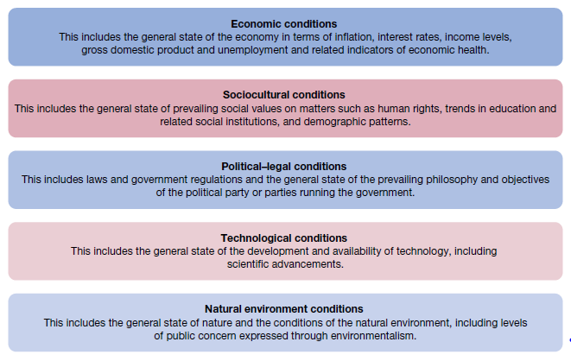

**Fig 5.4.1 Major elements of an organisation’s general environment**

While all of these forces in the general environment can influence business activities, three in particular have received much attention in recent times — economic, sociocultural and natural environment conditions. Managers need to keep a sharp eye out for such economic turbulence and make contingency plans. The natural environment has also emerged as an increasingly important issue, with the world as a whole generally becoming more aware of the need to minimise the impact of human and organisational behaviour on our planet. This issue, and its potential implications for managers, is discussed in more detail in the boxed feature.

## 5.5 Internal environment and organisational culture

*Culture* is a popular word in management these days. Important differences in national cultures are discussed in the chapter on the global dimensions of management. **Organisational culture** is the system of shared beliefs and values that develops within an organisation and guides the behaviour of its members. Sometimes called the *corporate culture*, it is a key aspect of any organisation and work setting. Whenever people speak, for example, of ‘the way we do things here, they are talking about the culture.

**What strong cultures do?**

Although it is clear that culture is not the sole determinant of what happens in organisations, it is an important influence on what they accomplish and how they accomplish it. The internal culture has the potential to shape attitudes, reinforce common beliefs, direct behaviour and establish performance expectations and the motivation to fulfil them. Organisational culture makes a major contribution to their long‐term performance records. Importantly, the cultures in these organisations provided for a clear vision of what the organisation was attempting to accomplish, allowing individuals to rally around the vision and work hard to support and accomplish it. In these and related ways, organisational culture is a bond that further mobilises resources for action.

Strong cultures — ones that are clear and well defined and widely shared among members — discourage dysfunctional work behaviours and encourage positive ones. They commit members to do things for and with one another that are in the best interests of the organisation, and then they reinforce these habits. The best organisations have strong cultures that show respect for members and encourage adaptability and continuous improvement in all areas of operations. They are likely to have cultures that are performance‐oriented, emphasise teamwork, allow for risk taking, encourage innovation and make the wellbeing of people a top management priority.

**Levels of organisational culture**

Organisational culture is usually described from the perspective of the two levels the ‘observable’ culture and the ‘core’ culture. The *observable culture* is visible — it is what one sees and hears when walking around an organisation as a visitor, a customer or an employee. In strong culture organisations the observable culture will be readily apparent. It can be seen in the way people dress at work, how they arrange their offices, how they speak to and behave towards one another, the nature of their conversations and how they talk about and treat their customers. More formally stated, the observable culture includes the elements of daily organisational life — through them, new members learn the organisation’s culture and all members share and reinforce its special aspects over time:

* *stories* — oral histories and tales, told and retold among members, about dramatic sagas and incidents in the life of the organisation
* *heroes* — the people singled out for special attention and whose accomplishments are recognised with praise and admiration among members; they include founders and role models
* *rites and rituals* — the ceremonies and meetings, planned and spontaneous, that celebrate important occasions and performance accomplishments
* *symbols* — the special use of language and other non‐verbal expressions to communicate important themes of organisational life.

Standing at the foundation of what can be observed directly in the daily life of an organisation is a second and deeper level of culture. This is the core culture, and it determines why things are the way they are. It consists of **core values** or underlying assumptions and beliefs that influence

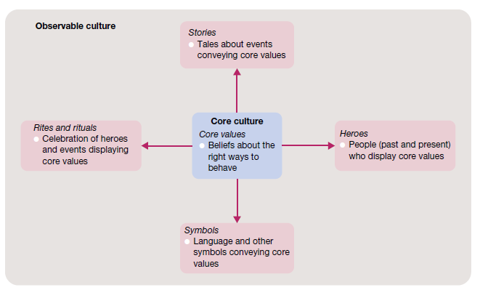

**Fig 5.5.1 Levels of organisational culture — observable culture and core culture**

behaviour and actually give rise to the aspects of observable culture just described. Values are essential to strong culture organisations and are often widely publicised in formal statements of corporate mission and purpose. Strong culture organisations operate with a small but enduring set of core values. The enduring commitment to core values is a major ingredient of organisations that achieve long‐term success. Highly successful companies typically emphasise the values of performance excellence, innovation, social responsibility, integrity, worker involvement, customer service and teamwork.

**Leadership and organisational culture**

Leadership of the organisational culture involves establishing and maintaining appropriate core values. Although this is most often considered a top management job, the same requirement holds for any manager or team leader at any level of responsibility. Just like the organisation as a whole, any work team or group will have a culture. How well this culture operates to support the group and its performance objectives will depend in part on the strength of the core values. At any level, these values should meet the test of three criteria: (i) *relevance* — core values should support key performance objectives; (ii) *pervasiveness* — core values should be known by all members of the organisation or group; and (iii) *strength* —core values should be accepted by everyone involved. Attention is increasingly being given to the concept of a **symbolic leader** — someone who uses symbols well to establish and maintain a desired organisational culture. Symbolic managers and leaders talk the ‘language’ of the organisation. They are always careful to use spoken and written words to describe people, events and even the competition in ways that reinforce and communicate core values.

*Language metaphors* — the use of positive examples from another context — are very powerful in this regard. Good symbolic leaders highlight the observable culture. They tell key stories over and over again, and they encourage others to tell them. They often refer to the ‘founding story’ about the entrepreneur whose personal values set a key tone for the business. They often talk about organisational heroes, past and present, whose performances exemplify core values. They often use symbolic rites and rituals that glorify the performance of the organisation and its members.

## 5.6 Ethics

**Ethics** can be defined as the code of moral principles that sets standards of good or bad, or right or wrong, in a person’s conduct and thereby guides the behaviour of that person or group. These principles guide behaviour and help people make moral choices among alternative courses of action. In practice, **ethical behaviour** is that which is accepted to be ‘good’, ‘right’ and ‘proper’ as opposed to ‘bad’, ‘wrong’ or ‘improper’ in the context of the governing moral code.

**Law, values and ethical behaviour**

It makes sense that there should be a legal component to ethical behaviour; that is, you would expect that any legal behaviour should be considered ethical. Furthermore, just because an action is not strictly illegal does not make it ethical. Living up to the ‘letter of the law’ is not sufficient to guarantee that your actions will or should be considered ethical. Is it truly .ethical, for example, for an employee to take longer than necessary to do a job? to make personal telephone calls on company time? to call in sick to take a day off for leisure? to fail to report rule violations by a co‐worker? None of these acts is strictly illegal, but many people would consider any one or all of them to be unethical. Most ethical problems in the workplace arise when people are asked to do, or find themselves about to do, something that violates the dictates of their conscience. For some, if the act is legal they proceed with confidence. For others, the ethical test goes beyond the legality of the act alone. The ethical question extends to personal **values** — the underlying beliefs and attitudes that help determine individual behaviour. Values vary among people.

**Alternative views of ethical behaviour**

There are many different interpretations of what constitutes ethical behaviour. The first is the **utilitarian view**. Behaviour that would be considered ethical from this perspective delivers the greatest good to the greatest number of people. Founded in the work of 19th century philosopher John Stuart Mill, this is a results oriented point of view that tries to assess the moral implications of decisions in terms of their consequences. Business decision makers, for example, are inclined to use profits, efficiency and other performance criteria to judge what is best for the most people. A manager may make a utilitarian decision to cut 30 per cent of a factory’s workforce in order to keep the factory profitable and save jobs for the remaining 70 per cent.

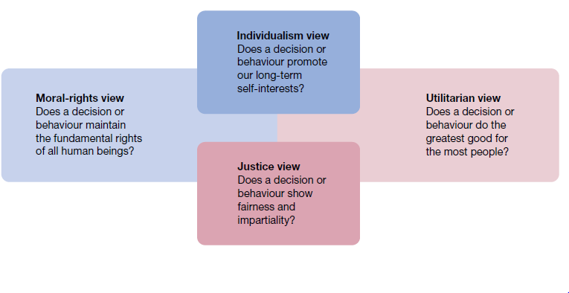

**Fig 5.6.1 Four views of ethical behaviour**

The **individualism view** of ethical behaviour is based on the belief that our main commitment is to the advancement of long‐term self‐interests. When people pursue individual self‐interests, they supposedly become self‐regulating. For example, such things as lying and cheating for short‐term gain should not be tolerated. If one person does it, everyone will do it, and no‐one’s long‐term interests will be served. The individualism view is supposed to promote honesty and integrity. But in business practice it may result in a pecuniary ethic, described by one business executive as the tendency to ‘push the law to its outer limits’ and ‘run roughshod over other individuals to achieve one’s objectives.

Ethical behaviour under a **moral‐rights view** is that which respects and protects the fundamental rights of people. In many organisations today, this concept extends to ensuring that employees are always protected in their rights to privacy, due process, free speech, free consent, health and safety, and freedom of conscience. The issue of human rights, so characteristic of ethical concerns in the international business environment, is central to this perspective.

The United Nations stands by the Universal Declaration of Human Rights passed by the General Assembly in 1948. People are not a cost; they are a resource. Considerations for workers in and out of the workplace are the responsibility of the corporate leader just as much as the profits, survival, and growth of the business or organisation. Finally, the **justice view** of moral behaviour is based on the belief that ethical decisions treat people impartially and fairly according to guiding rules and standards. This approach evaluates the ethical aspects of any decision on the basis of whether it is ‘equitable’ for everyone affected. One justice issue in organisations is **procedural justice** — the degree to which policies and rules are fairly administered. A second issue is **distributive justice** — the degree to which outcomes are allocated without respect to individual characteristics based on ethnicity, race, gender, age or other criteria. A third issue is **interactional justice** — the degree to which others are treated with dignity and respect.

**Cultural issues in ethical behaviour**

The influence of culture on ethical behaviour is increasingly at issue as businesses and individuals travel the world. Corporate leaders must master difficult challenges when operating across borders that are cultural as well as national. Those who believe that behaviour in foreign settings should be guided by the classic rule of ‘when in Rome, do as the Romans do’ reflect an ethical position of **cultural relativism**. This is the notion that there is no one right way to behave and that ethical behaviour is always determined by its cultural context. When it comes to international business, for example, a Western executive guided by rules of cultural relativism might argue that the use of child labour is okay if it is consistent with local laws and customs.

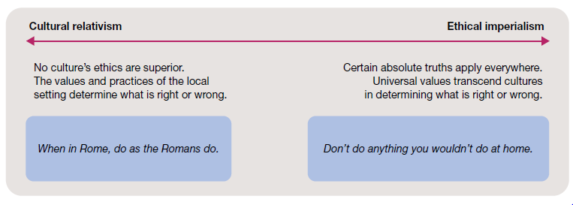

Fig 5.6.2 The extremes of cultural relativism and ethical imperialism

However, contrasts this position with the alternative of **universalism**. This ethical position suggests that if a behaviour or practice is not okay in your home environment, it shouldn’t be acceptable practice anywhere else. In other words, ethical standards are universal and should apply absolutely across cultures and national boundaries. Critics of such a universal approach claim that it is a form of **ethical imperialism**, or the attempt to externally impose your ethical standards on others.

Although there is no simple answer, it is possible both extremes have faults. Certain fundamental rights and ethical standards can be preserved while values and traditions of a given culture are respected. The core values or ‘hyper‐norms’ that should transcend cultural boundaries focus on human dignity, basic rights and good citizenship. With a commitment to core values creating a transcultural ethical umbrella, international business behaviours can be tailored to local and regional cultural contexts.

**Ethics in the workplace**

‘Ethical business is good business’ is a classic quote. The same can be said for all persons and institutions throughout society. But the real test is when managers or workers encounter a situation that challenges their ethical beliefs and standards. Often ambiguous and unexpected, these ‘ethical dilemmas’ are part of the challenge of modern society.

**What is an ethical dilemma?**

An ethical dilemma occurs when our own behaviour, or the behaviour we witness from others, conflicts with our values and beliefs. Such dilemmas cause stress to us until they are resolved. An **ethical dilemma** arises when action must be taken but there is no clear ‘ethically right’ option. The burden is on the individual to make good choices. An engineering manager, speaking from experience, sums it up this way: ‘I define an unethical situation as one in which I have to do something I dont feel good about.’

**Ethical problems faced by managers**

There are many potential sources of discomfort in managerial decision‐making, including those with ethical overtones. Some of the problem areas or situations where managers can get caught in ethical dilemmas include:

* *discrimination* — where a manager denies promotion or appointment to a job candidate because of the candidate’s race, religion, gender, age or other criterion not relevant to the job
* *sexual harassment* — where a manager makes a co‐worker feel uncomfortable because of inappropriate comments or actions regarding sexuality.
* *conflicts of interest* — where a manager takes a bribe or kickback or extraordinary gift in return for making a decision favourable to the gift giver
* *customer confidence* — where a manager has privileged information regarding the activities of a customer and shares that information with another party
* *organisational resources* — where a manager uses official stationery or a company email account to communicate personal opinions or requests to community organisations.

Often many of the ethical dilemmas reported by managers involved conflicts with superiors, customers and subordinates. The most frequently occurring issues involved dishonesty in advertising and communications with top management, clients and government agencies. problems in dealing with special gifts, entertainment and kickbacks. The managers’ bosses were sometimes pressure their subordinates to engage in such unethical activities as supporting incorrect viewpoints, signing false documents, overlooking the boss’s wrongdoings and doing business with the boss’ friends.

**Rationalisations for unethical behaviour**

Why might otherwise reasonable people act unethically? Think back to the earlier examples and to those from your experiences. Consider the possibility of being asked to place a bid for a business contract using insider information, paying bribes to obtain foreign business, falsifying expense account bills, and so on. ‘Why’, you should be asking, ‘do people do things like this?’ In fact, there are at least four common rationalisations that are used to justify misconduct in these and other ethical dilemmas.

i. Convince yourself that the behaviour is not really illegal.

ii. Convince yourself that the behaviour is really in everyone’s best interests.

iii. Convince yourself that nobody will ever find out what you’ve done.

iv. Convince yourself that the organisation will ‘protect’ you.

After doing something that might be considered unethical, a rationaliser says, ‘It’s not really illegal. This expresses a mistaken belief that your behaviour is acceptable, especially in ambiguous situations. When dealing with ‘shady’ or borderline situations in which you are having a hard time defining precisely what is right and what is wrong, the advice is quite simple. When in doubt about a decision to be made or an action to be taken, don’t do it. Another common statement by a rationaliser is: ‘It’s in everyone’s best interests’. This response involves the mistaken belief that because someone can be found to benefit from the behaviour, the behaviour is also in the individual’s or the organisation’s best interests. Overcoming this rationalisation depends in part on the ability to look beyond short‐term results to consider longer term implications, and to look beyond results in general to the ways in which they are obtained.

Lack of accountability, unrealistic pressures to perform and a boss who prefers ‘not to know’ can all reinforce such thinking. In this case, the best deterrent is to make sure that everyone knows that wrongdoing will be punished whenever it is discovered. Rationalisers may proceed with a questionable action because of a mistaken belief that ‘the organisation will stand behind me’. This is misperceived loyalty. The individual believes that the organisation’s best interests stand above all others. In return, the rationaliser thinks that top managers will condone the behaviour and protect the individual from harm. But loyalty to the organisation is not an acceptable excuse for misconduct; organisational loyalty should not stand above the law and social morality.

**Factors influencing ethical behaviour**

In practice, people are often challenged to choose ethical courses of action in situations where the pressures may be contradictory and great. Increased awareness of the factors influencing ethical behaviour can help in dealing with them more appropriately.

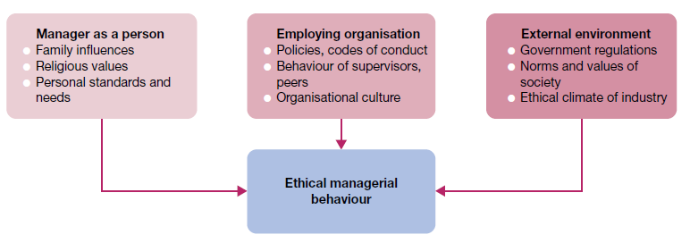

**Fig 5.6.3 Factors influencing ethical managerial behaviour — the person, organisation and environment**

**The person**

Family influences, religious values, personal standards and personal needs, financial and otherwise, will help determine a person’s ethical conduct in any given circumstance. Managers who lack a strong and consistent set of personal ethics will find that their decisions vary from situation to situation as they strive to maximise self‐interests. Those who operate within strong ethical frameworks (personal rules or strategies for ethical decision‐making) will be more consistent and confident since choices are made against a stable set of ethical standards.

**The organisation**

The organisation is another important influence on ethics in the workplace. The first port of call is at the staff selection stage. Unethical or unsavoury characters should not be recruited and appointed in the first instance. The expectations and reinforcement provided by peers and group norms are likely to have a similar impact. Formal policy statements and written rules are also very important in establishing an ethical climate for the organisation as a whole. They support and reinforce the organisational culture, which can have a strong influence on members’ ethical behaviour.

**The environment**

Organisations operate in external environments composed of competitors, government laws and regulations, and social norms and values, among other influences. Laws interpret social values to define appropriate behaviours for organisations and their members; regulations help governments monitor these behaviours and keep them within acceptable standards. The climate of competition in an industry sets a standard of behaviour for those who hope to prosper within it. Sometimes the pressures of competition contribute further to the ethical dilemmas of managers.

**Maintaining high ethical standards**

Progressive organisations support a variety of methods for maintaining high ethical standards in workplace affairs. Some of the most important efforts in this area involve ethics training, whistleblower protection, top management support, formal codes of ethics and strong ethical cultures.

**Ethics training**

**Ethics training**, in the form of structured programs to help participants understand the ethical aspects of decision‐making, is designed to help people incorporate high ethical standards into their daily behaviour. Many ethical dilemmas arise as a result of the time pressures of decisions. Ethics training is designed to help people deal with ethical issues while under pressure. The decision‐making process includes responsibility for double‐checking a decision before taking action. The key issue is the risk of public disclosure of your action and your willingness to bear it. This is a strong way to test whether a decision is consistent with your personal ethical standards

**Whistleblower protection**

**Whistleblowers**, are people who expose the misdeeds of others in organisations in order to preserve ethical standards and protect against wasteful, harmful or illegal acts. Whistleblowers face the risks of impaired career progress and other forms of organisational retaliation, up to and including dismissal. Many workers become whistleblowers unintentionally when reporting workplace fraud, corruption or maladministration. But although signs indicate that the courts are growing supportive of whistleblowers, legal protection for them can still be inadequate. Laws vary from state to state, and federal laws mainly protect government workers.

Furthermore, even with legal protection, potential whistleblowers may find it hard to expose unethical behaviour in the workplace. Some organisational barriers to whistleblowing include a *strict chain of command* that makes it hard to bypass the boss, *strong work group identities* that encourage loyalty and self‐censorship, and *ambiguous priorities* that make it hard to distinguish right from wrong. In the attempt to remove these and other blocks to the exposure of unethical behaviours, some organisations have formally appointed staff members to serve as ‘ethics advisers’. Others have set up formal staff units to process reported infractions. One novel proposal goes so far as to suggest the convening of *moral quality circles* to help create shared commitments for people to work at their moral best.

**Ethical role models**

Top managers in large and small businesses have the power to shape their organisation’s policies and set its moral tone. They also have a major responsibility to use this power well. They can and should serve as role models of appropriate ethical behaviour for the entire organisation. Not only must their day‐to‐day behaviour be the epitome of high ethical conduct, but top managers must also c

mmunicate similar expectations throughout the organisation, and reinforce positive results. Unfortunately, communication from the top may subtly suggest that top management does not want to know about deceptive or illegal practices by employees, or simply doesn’t care. Even though top managers bear a special responsibility for setting the ethical tone of an organisation, every manager is also in a position to influence the ethical behaviour of the people who work for and with them. All managers must act as ethical role models and set an ethical tone in their areas of responsibility. Care must be taken to do this in a positive and informed manner. The important supervisory act of setting goals and communicating performance expectations is a good case in point. Clearly, any manager, in his or her relationships with subordinates, may unknowingly encourage unethical practices by exerting too much pressure for them to accomplish goals that are too difficult. Part of the manager’s ethical responsibility is to be realistic in setting performance goals for others.

**Codes of ethics**

Formal **codes of ethics** are official written guidelines on how to behave in situations susceptible to the creation of ethical dilemmas. They are found in organisations and in professions such as engineering, medicine, law and public accounting. In the professions such as accounting and engineering, ethical codes try to ensure that individual behaviour is consistent with the historical and shared norms of the professional group.

Most codes of ethical conduct identify expected behaviours in terms of general organisational citizenship, the avoidance of illegal or improper acts in a person’s work, and good relationships with customers. Codes, include workforce diversity, bribes and kickbacks, political contributions, the honesty of books or records, customer–supplier relationships and the confidentiality of corporate information. In the increasingly complex world of international business, codes of conduct for manufacturers and contractors are becoming more prevalent.

A sample formal Code of Vendor Conduct, among the many areas covered, the document specifically deals with:

* *discrimination* — stating ‘Factories shall employ workers on the basis of their ability to do the job, not on the basis of their personal characteristics or beliefs’
* *forced labour* — stating ‘Factories shall not use any prison, indentured or forced labour’
* *working conditions* — stating ‘Factories must treat all workers with respect and dignity and provide them with a safe and healthy environment’
* *freedom of association* — stating ‘Factories must not interfere with workers who wish to lawfully and peacefully associate, organize or bargain collectively.

The codes have limits. They cannot cover all situations, and they are not automatic insurance for universal ethical conduct. But they do play important roles in setting the ethical tone and expectations in organisations. When fully integrated into the organisational culture, furthermore, the moral fabric created has a strong influence on day‐to‐day behaviour. And there is no replacement for leadership by committed managers who are willing to set examples and act as positive ethical role models to ensure desired results.